Department of Computer Engineering
Object Oriented Programming
Hw#1

Instructor : Haya Sammaneh

Q1: Implement the following class diagram by using HashMap class.
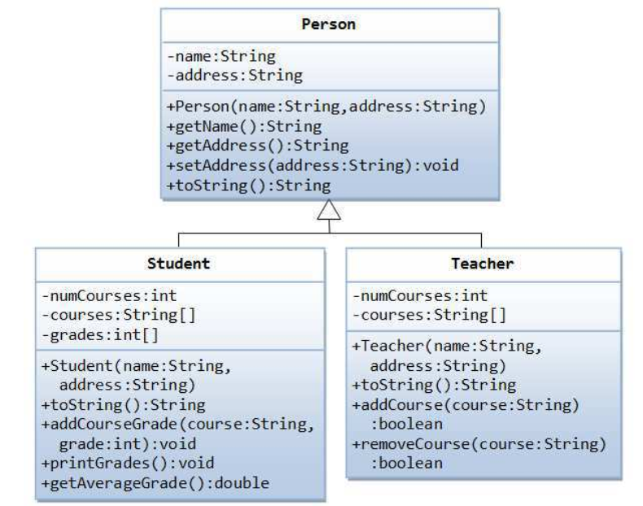
Q2: Write a Java class NODE that represent a shape that may be a line , rectangle or a circle. The class must store the dimensions of the shape and the type as integer.

Override the method toString() to convert the shape to a string which show all the information

Write the class STACK which implemented as linked list of nodes with all functions Push, POP and Print.

Write the main and use the basic operations of the STACK to push and pop shapes.

Total Marks: 10 marks.
Deadline: 31/10/2019

